EXPERIMENT 1

Jai Prasadh

PHY 115L

INTRODUCTION

In this experiment I sought to learn about simple vibrational phenomena. I explored the transverse modes of a spring to determine the relationship between mode and frequency, and calculated velocities based on these measurements which I compared to the propagation velocity I calculated from a single pulse. I then focused on vibrations of a string, which I viewed the waveform for in a variety of tensions, lengths, and pluck types to see the effects of each of these on the frequencies produced. I used these observations to procure a function describing their relationships.

RESULTS

Vibrations of a Spring:

I determined the following frequencies for each mode of the spring, calculated from measurements I took on the scale length (distance between adjacent nodes) and the time for 10 oscillations. Please refer to figures 1 and 2 for the plotted relationship between frequency and scale length, and frequency and the inverse of scale length, respectively.

|  |  |  |
| --- | --- | --- |
| Mode | Frequency (Hz) | δ (Hz) |
| 1 | 0.87 | 0.02 |
| 2 | 1.9 | 0.1 |
| 3 | 2.7 | 0.2 |

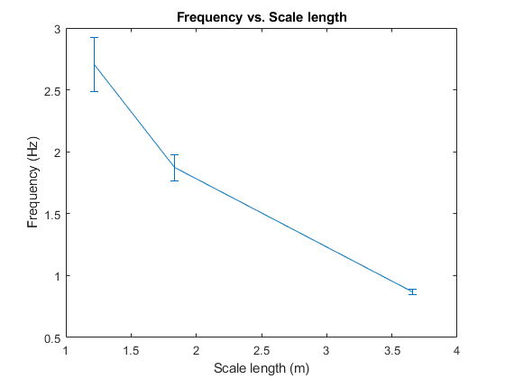

Figure

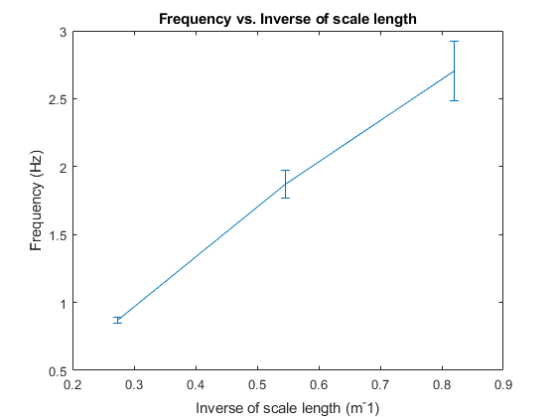

Figure

From these figures, it appears as if frequency is proportional to the inverse of the distance between the nodes, i.e. a shorter scale length results in a higher frequency.

Subsequently, I calculated the wave velocity for each mode, using the relationship $v= λf$, with the wavelength (lambda) being twice the distance between the nodes, i.e. twice the scale length. I then compared the calculated velocities to the velocity of a single pulse down the same spring which I computed separately. The measurement for the pulse relied on human reaction time to capture the timing so there is more uncertainty there.

|  |  |  |
| --- | --- | --- |
| Mode | Velocity (m/s) | δ (m/s) |
| 1 | 6.4 | 0.2 |
| 2 | 6.9 | 0.4 |
| 3 | 6.6 | 0.5 |
| Pulse | 6.5 | 2 |

These velocities are remarkably similar, which makes sense since pulses and waves travel at the propagation velocity of the medium, which in this case is determined by the spring itself.

Vibrations of a String:

I plucked the string in many ways, resulting in a variety of sounds produced which was reflected in what I heard as well as what was displayed by the monitor equipment and the Fourier transform. Please consult figures 3, 4, and 5 to see what I discuss about these effects.

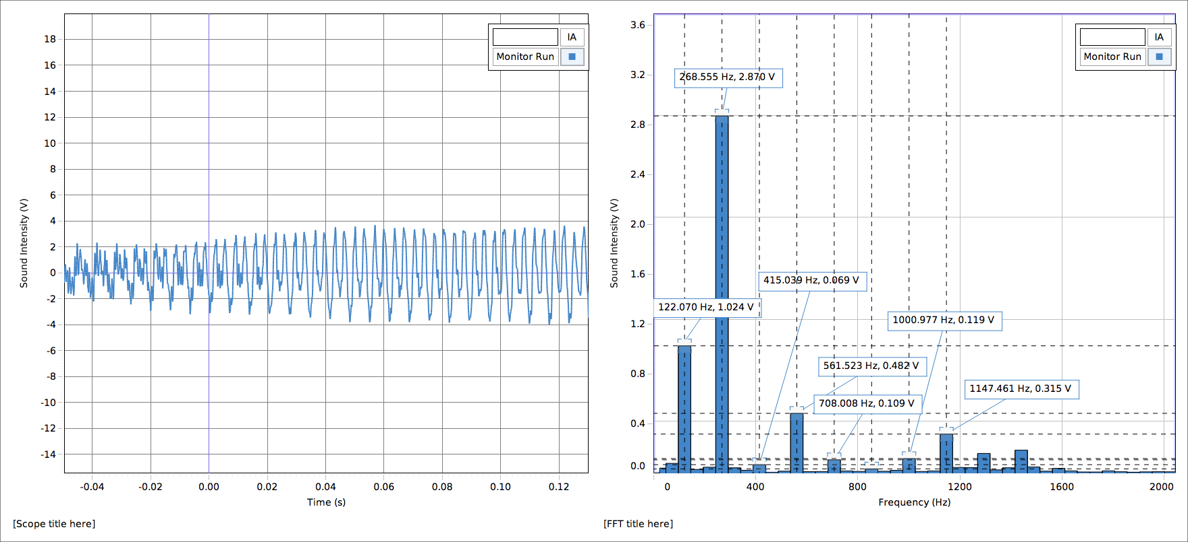

Figure

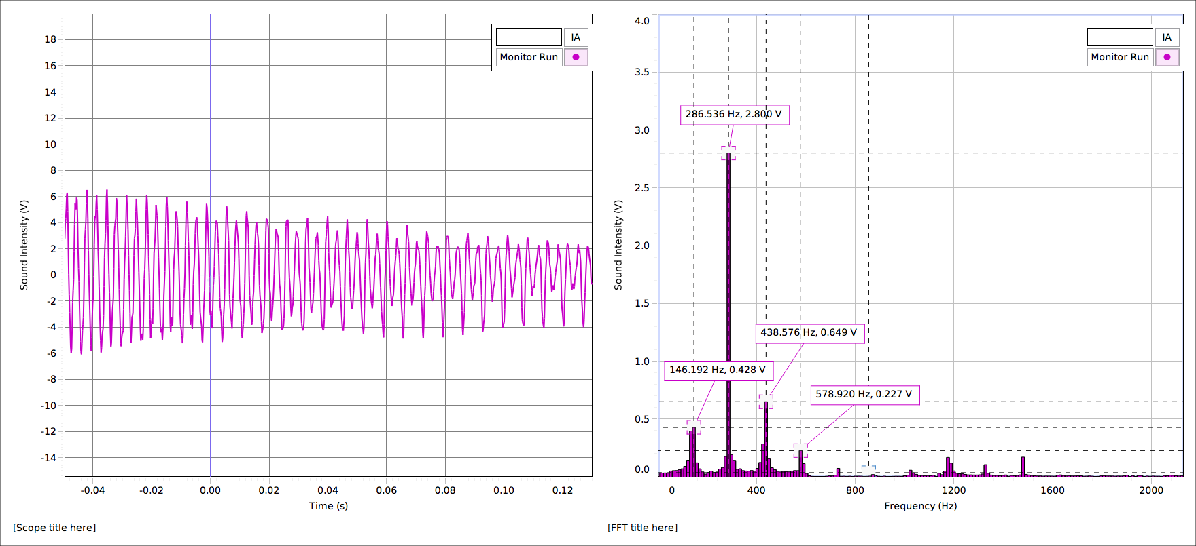

Figure

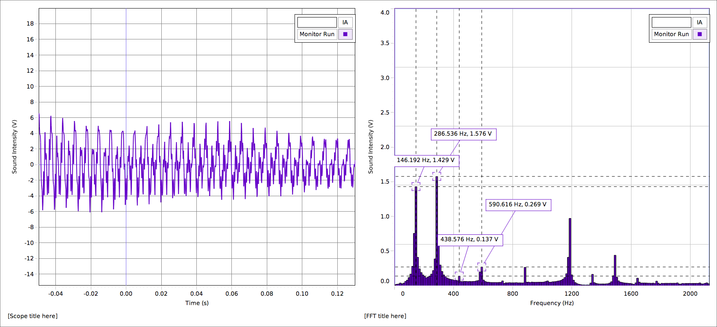

Figure

In the first pluck (figure 1), I had the string set up the maximum length the instrument allowed. I didn’t try to pluck it in any particular way, so the pluck did have a reasonable amount of noise coming from other harmonics. In figure 2, I took care to pluck the string with the fleshy part of my finger, about in the middle of the string, away from either bridge. This produced a much cleaner, purer sound, which was reflected in the sharp, distinct, and few peaks of the Fourier transform. In figure 3, I plucked the string forcefully with the backside of my fingernail and very close to one of the bridges. This produced a much rougher, dirtier tone. The Fourier transform accordingly had a lot of higher harmonic content compared to the clean pluck. Between the pluck styles, the location of the harmonic frequencies stayed the same but the composition or relative amounts of each signal differed.

In each case, the fundamental frequency was easy to identify because it was the frequency that lingered longest as the sound decayed in the Fourier transform. A reason for this may be that higher harmonics take more energy to maintain so they are easily lost as the wave loses energy over time when compared to the lower frequency fundamental.

After experimenting with plucks, I devised relationships between string length and fundamental frequency at constant tension and between tension and fundamental frequency at constant string length.

|  |  |  |
| --- | --- | --- |
| Tension (N) | 44.6 |  |
| String length (m) | Fundamental frequency (Hz) | δ (Hz) |
| 0.65 | 140 | 3 |
| 0.60 | 152 | 3 |
| 0.55 | 167 | 3 |
| 0.50 | 184 | 3 |
| 0.45 | 204 | 3 |
| 0.575 | 159 | 3 |

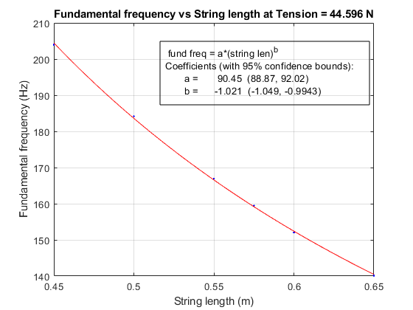

Figure

|  |  |  |
| --- | --- | --- |
| String length (m) | 0.50 |  |
| Tension (N) | Fundamental frequency (Hz) | δ (Hz) |
| 44.6 | 184 | 3 |
| 39.7 | 174 | 3 |
| 34.8 | 162 | 3 |
| 29.9 | 150. | 3 |
| 25.0 | 137 | 3 |
| 20.1 | 122 | 3 |

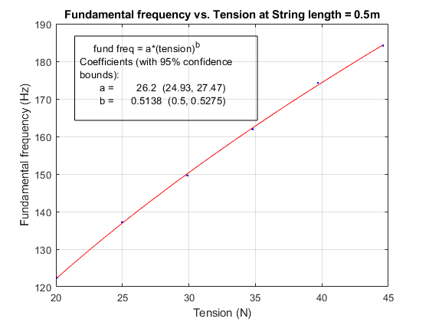

Figure

I plotted several of my observations and fitted curves to each plot. From figure 6, it is apparent that the fundamental frequency of a vibration on a string is proportional to the inverse of string length, and from figure 7 it seems that the fundamental frequency is proportional to the square root of tension, i.e. $f∝ \frac{\sqrt{T}}{L}$ for fundamental frequency f, tension T, and string length L.

SUMMARY

I was successful in investigating wave phenomena of springs and strings in this experiment. My results for each objective detailed in the introduction matched what I expected given my knowledge of the topic from the course as well as my own predictions. A further question for a future experiment raised by my findings here is the nature of the proportionality constant between frequency, string length, and string tension.